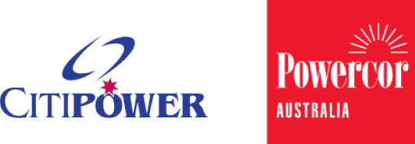
Certificate

Option 2 Contractor Rating Program
Derived from the CitiPower and Powercor Field Audit & Quality auditing program, the rating(s) awarded reflect the company nominated below in relation to managing or auditing contestable Customer Initiated Augmentation Works (Option 2).

CitiPower and Powercor declares that

Company Name

Is awarded the following performance rating based on project audits completed during the qualifying three-month period of 01/07/2021 – 30/09/2021 (which is calculated & updated on quarterly basis)
Role | Completed Projects | Category | Performance | Score | Previous Performance
Project Manager | 14 | B | Acceptable | 91.3 | Proficient
Companies must have completed three or more projects in the rating period for the audit rating scheme to apply
Industry Average:
The industry average performance rating is are based on project audits completed during the qualifying three-month period of 01/07/2021 – 30/09/2021 (which is calculated and update on quarterly basis)
Role | Category | Performance | Score | Previous Performance
Project Manager | A | Proficient | 97.2 | Proficient

Date of issue:
XXX
(This certificate is valid for three months from the date of issue)
Issued by:
Field Audit & Quality, Powercor
fieldauditandquality@powercor.com.au

