How to apply for Embedded Networks up to 200kVA

This instruction steps you through how to apply for Embedded Networks up to 200kVA via eConnect.

# Log into eConnect



# Navigate to the side bar and under ‘Embedded Generation & Battery Connection Approval’, select ‘Embedded Generation for Embedded Network’

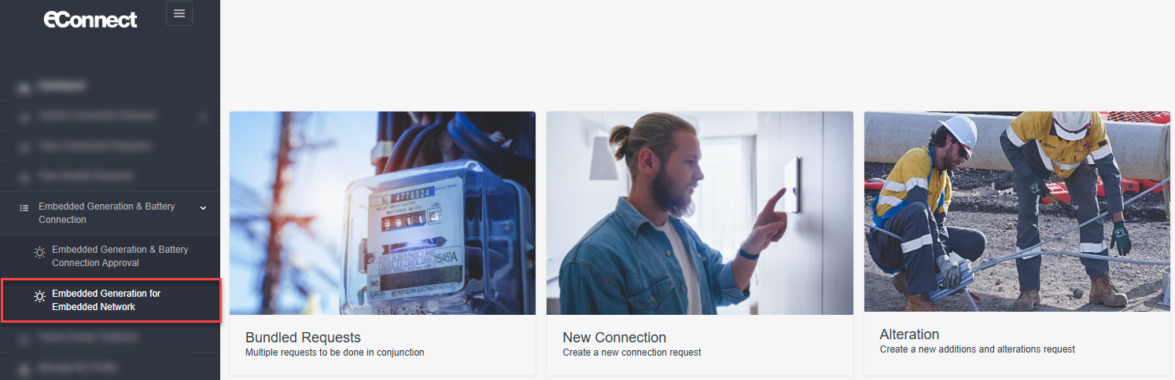

# Confirm site location details

* Search for site by the Embedded Network Parent NMI or Meter Number. This will populate the address.
* Confirm the address matches the property you are applying for.

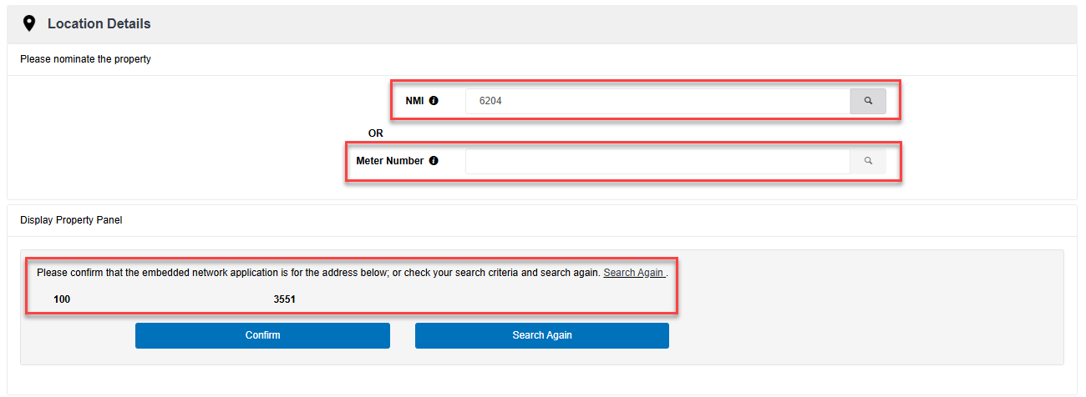

# Enter Work Requirements

Complete all fields under ‘**Work requirements’**, referring to the table below for guidance.

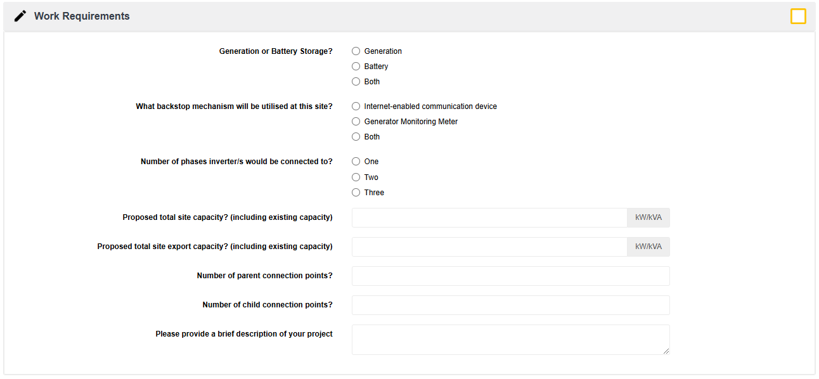

|  |  |
| --- | --- |
| **Work Requirements field** | **Description** |
| **Generation or battery storage?** | Select the Generation type. |
| **What backstop mechanism will be utilised at this site?** | Select the preferred backstop mechanism. |
| **Number of phases inverter/s would be connected to?** | How many phases will have solar connected? |
| **Proposed total site capacity? (including existing capacity)** | What is the total inverter rated output for the site? If this is an upgrade, please factor in the existing installation plus the proposed new installation. |
| **Proposed total site export capacity? (including existing capacity)** | What is the total proposed export for the site? If this is an upgrade, please factor in the existing export approval plus the proposed new export capacity. |
| **Number of parent connection points?** | How many parent meters are registered at this site? |
| **Number of child connection points?** | How many individual child meters are installed within the embedded network? |
| **Please provide a brief description of your project** | Provide an overview of the installation. |

# Enter Contact Details

* If you are the registered electrical contractor or a licensed electrical worker for the application, select ‘**Yes**’.

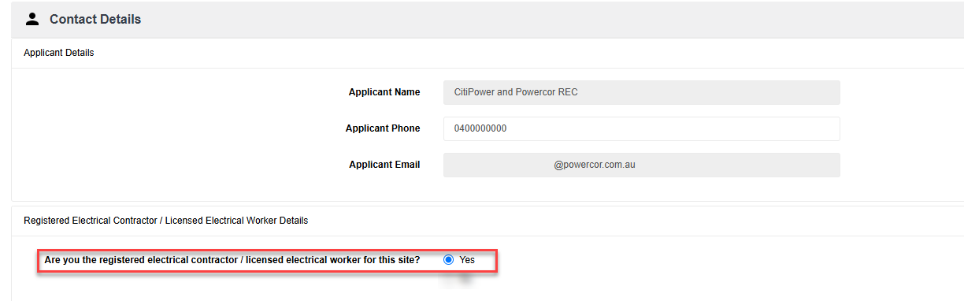

* If you would like to appoint another party as the registered electrical contractor or the licensed electrical worker for the application, select ‘**No**’.
* Enter their contact details.

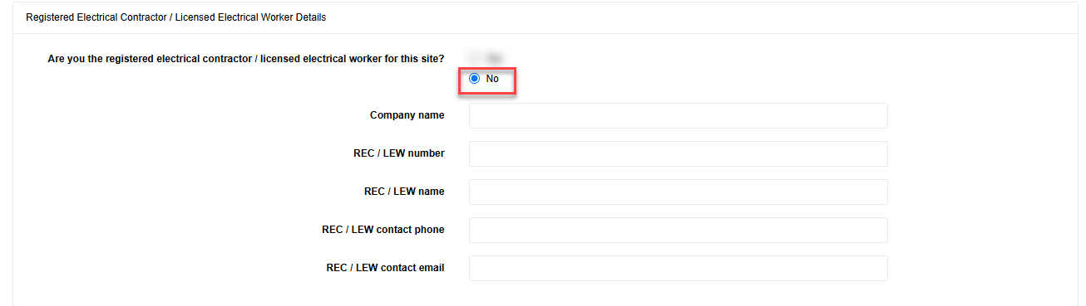

* Complete all fields under the ‘**Embedded Network Provider Details’** section.

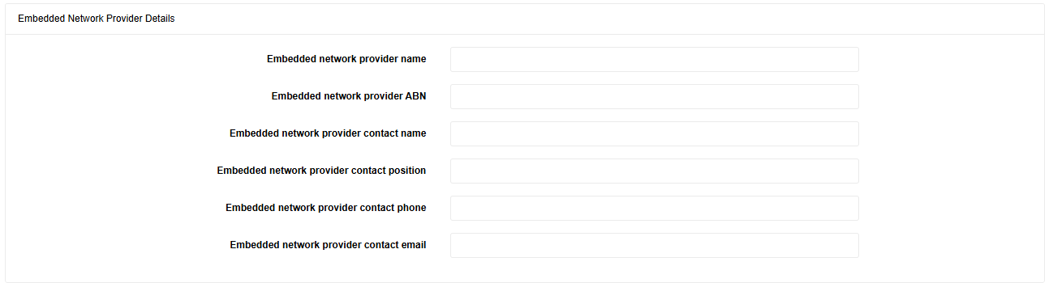

# Attachments

Provide all supporting documents listed at the top of the application.

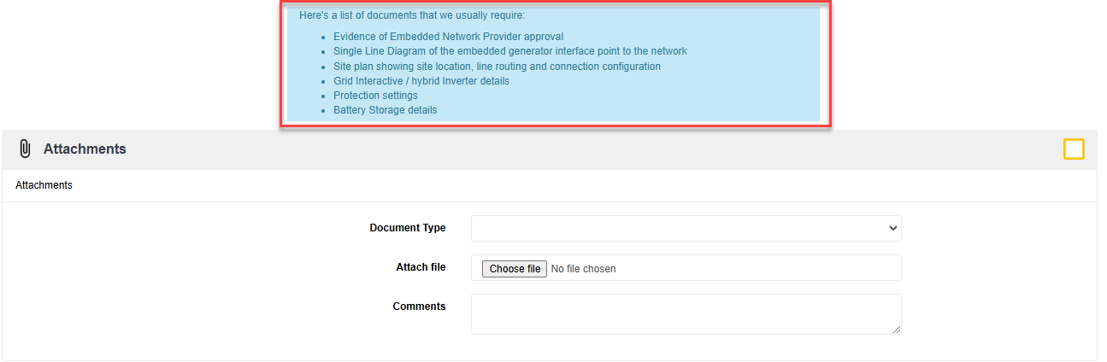

Each document must be uploaded individually, selecting the relevant document from the drop-down under ‘Document Type’.

# Application submission

* Ensure you read all the Terms and Conditions then click the acceptance box.
* Click the ‘Submit’ button to complete the application.

